**Take screenshots of the completed programming exam (python code and output in python shell), paste them into a word document and upload it. Please submit your assignment with the naming convention of Lastname_Firstname_Practice_Programming_Exam2.docx.**

**All Output**

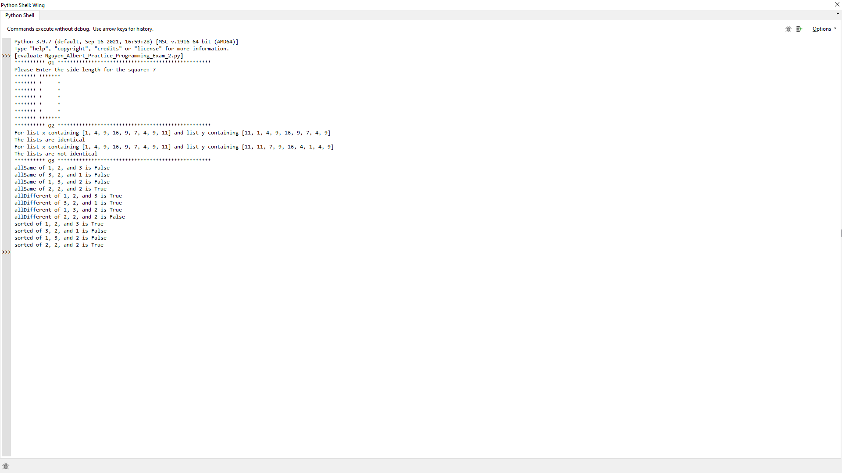

**10 points**

Organization of the code such as proper commenting out, meaningful variable names, declaring and calling functions such as calling helper functions in main function, following PEP 8 design, clean code, submitting the word document with properly pasted python code and output etc.

**30 points**

**Q1.** Write a program that reads an integer and displays, using asterisks, a filled and hollow square, placed next to each other.

**Here is a sample dialog**

Please Enter the side length for the square: 7

******* *******

******* * *

******* * *

******* * *

******* * *

******* * *

******* *******

**Q1 Code**

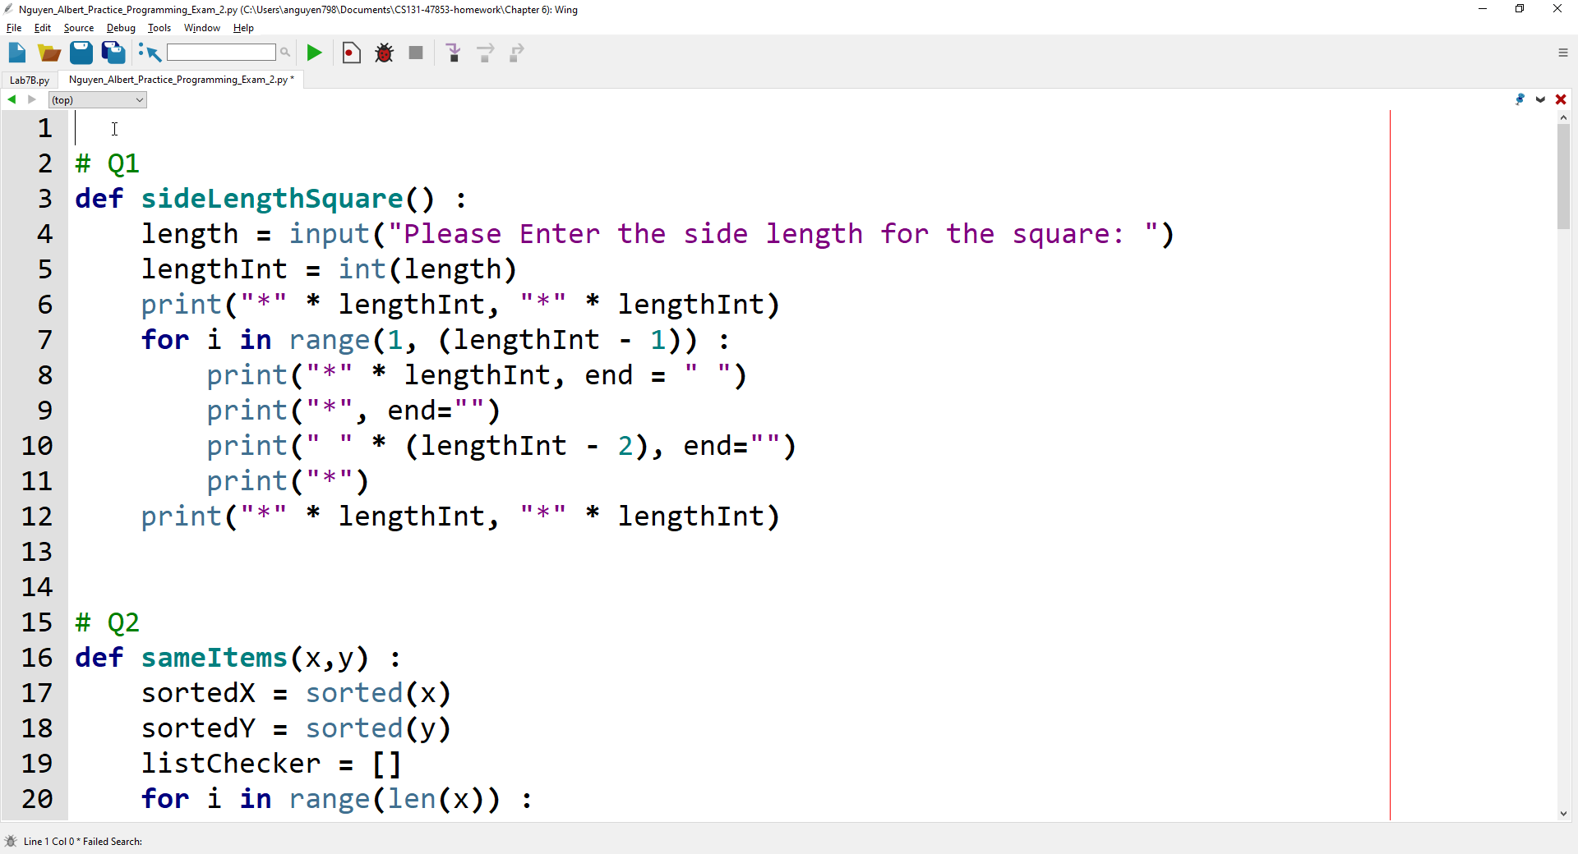

**Q1 Cropped Output**



**Q1 Code_Actual/Call**

**def sideLengthSquare() :**

length = input("Please Enter the side length for the square: ")

lengthInt = int(length)

print("*" * lengthInt, "*" * lengthInt)

for i in range(1, (lengthInt - 1)) :

print("*" * lengthInt, end = " ")

print("*", end="")

print(" " * (lengthInt - 2), end="")

print("*")

print("*" * lengthInt, "*" * lengthInt)

**def main() :** # cropped to exclude Q2 and Q3 (see Q2 and Q3 for respective calls)

# Q1 Calls

print("*" * 10, "Q1", "*" * 50)

sideLengthSquare()

**30 points**

**Q2.** Write a function def sameItems(x,y) that checks whether two lists have the same elements in some order, with the same multiplicities.

1 4 9 16 9 7 4 9 11

and

11 1 4 9 16 9 7 4 9

would be considered identical, but

1 4 9 16 9 7 4 9 11

and

would not.

**Q2 Code**

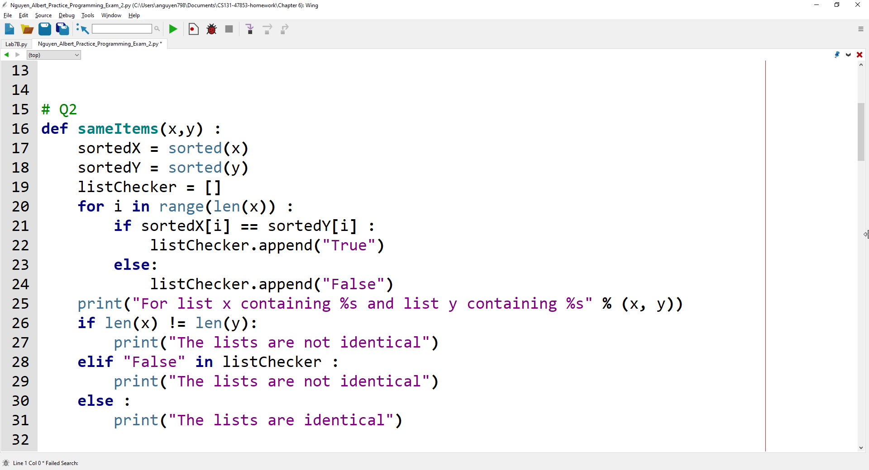**Here is a sample dialog**

List 1 is [1, 2, 1, 1, 2]

List 2 is [1, 1, 1, 2, 2]

The lists contain the same elements: True

**Q2 Cropped Output**



**Q2 Code Actual/Call**

**def sameItems(x,y)** :

sortedX = sorted(x)

sortedY = sorted(y)

listChecker = []

for i in range(len(x)) :

if sortedX[i] == sortedY[i] :

listChecker.append("True")

else:

listChecker.append("False")

print("For list x containing %s and list y containing %s" % (x, y))

if len(x) != len(y):

print("The lists are not identical")

elif "False" in listChecker :

print("The lists are not identical")

else :

print("The lists are identical")

**def main()** : # cropped to exclude Q1 and Q3 (see Q1 and Q3 for respective calls)

# Q2 Calls

print("*" * 10, "Q2", "*" * 50)

# First Call

x = [1, 4, 9, 16, 9, 7, 4, 9, 11]

y = [11, 1, 4, 9, 16, 9, 7, 4, 9]

sameItems(x,y)

y = [11, 11, 7, 9, 16, 4, 1, 4, 9]

# Second Call

sameItems(x,y)

**30 points**

**Q3.** Write the following functions and provide a python program to test them.

a. def allSame(a, b, c) (returning true if the arguments are all the same)

b. def allDifferent(a, b, c) (returning true if the arguments are all different)

c. def sorted(a, b, c) (returning true if the arguments are sorted, with the smallest one coming first)

**Here is a sample dialog**

allSame of 1, 2, and 3 is False

allSame of 3, 2, and 1 is False

allSame of 1, 3, and 2 is False

allSame of 2, 2, and 2 is True

allDifferent of 1, 2, and 3 is True

allDifferent of 3, 2, and 1 is True

allDifferent of 1, 3, and 2 is True

allDifferent of 2, 2, and 2 is False

sorted of 1, 2, and 3 is True

sorted of 3, 2, and 1 is False

sorted of 1, 3, and 2 is False

sorted of 2, 2, and 2 is True

**Q3 Code**

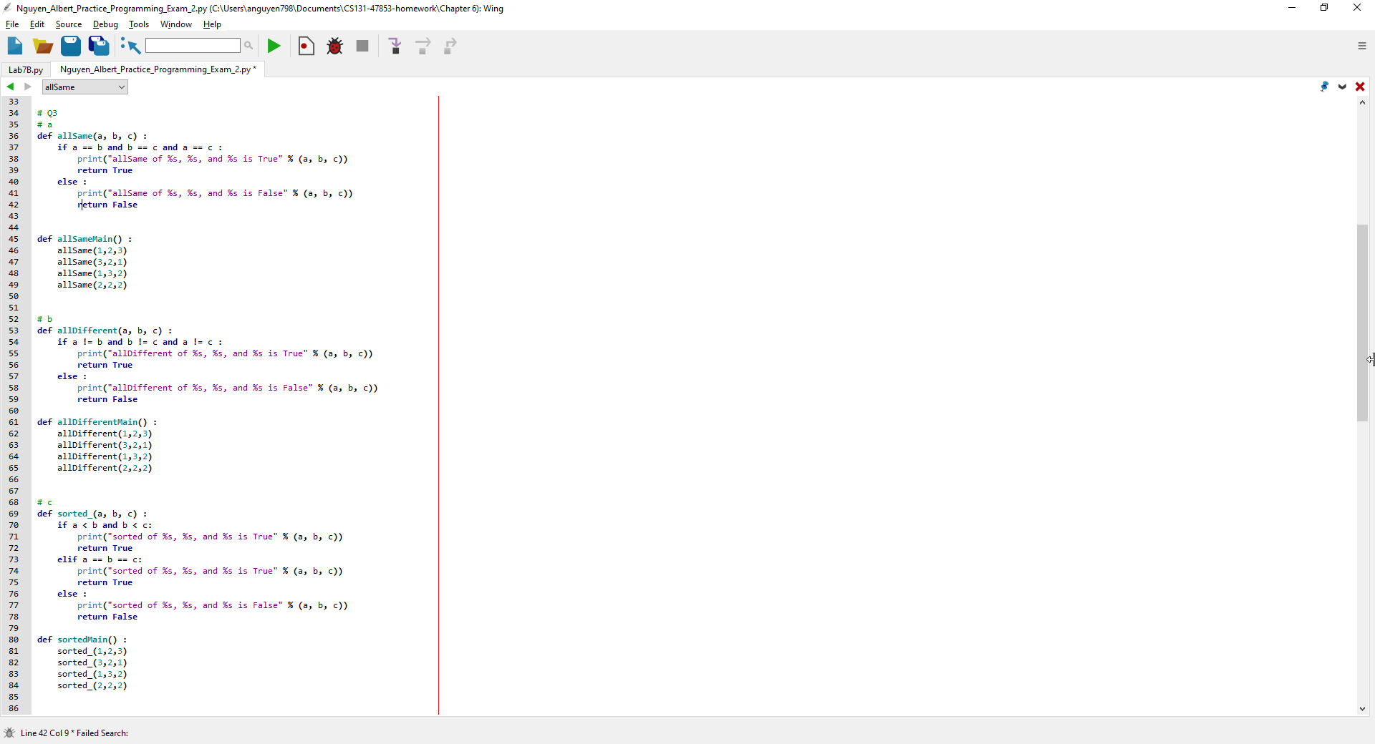

**Q3 Cropped Output**



**Q2 Code Actual/Call**

# Q3

# a

**def allSame(a, b, c)** :

if a == b and b == c and a == c :

print("allSame of %s, %s, and %s is True" % (a, b, c))

return True

else :

print("allSame of %s, %s, and %s is False" % (a, b, c))

return False

**def allSameMain()** :

allSame(1,2,3)

allSame(3,2,1)

allSame(1,3,2)

allSame(2,2,2)

# b

def allDifferent(a, b, c) :

if a != b and b != c and a != c :

print("allDifferent of %s, %s, and %s is True" % (a, b, c))

return True

else :

print("allDifferent of %s, %s, and %s is False" % (a, b, c))

return False

def allDifferentMain() :

allDifferent(1,2,3)

allDifferent(3,2,1)

allDifferent(1,3,2)

allDifferent(2,2,2)

# c

def sorted_(a, b, c) :

if a < b and b < c:

print("sorted of %s, %s, and %s is True" % (a, b, c))

return True

elif a == b == c:

print("sorted of %s, %s, and %s is True" % (a, b, c))

return True

else :

print("sorted of %s, %s, and %s is False" % (a, b, c))

return False

def sortedMain() :

sorted_(1,2,3)

sorted_(3,2,1)

sorted_(1,3,2)

sorted_(2,2,2)

**def main()** : # cropped to exclude Q1 and Q2 (see Q1 and Q2 for respective calls)

#Q3 Calls

print("*" * 10, "Q3", "*" * 50)

allSameMain()

allDifferentMain()

sortedMain()